**CN LAB 04**

**BASIL ALI KHAN**

**20K-0477**

**Task#01:**

Age Header: The Age HTTP Header used to specify the amount of time in seconds that an item cached in the server's cache.

Expires: Expires header used to specify a specific point in time the resource is no longer valid.

**Task#02:**

There are four types of HTTP message headers:

1. General-header
2. Client Request-header
3. Server Response-header
4. Entity-header

**Task#03:**

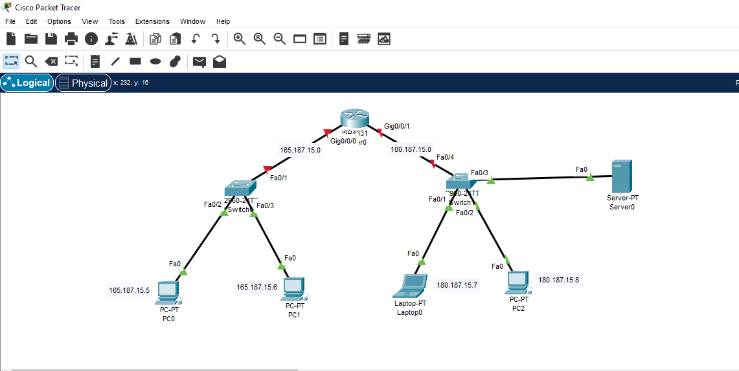

**Task#04:**

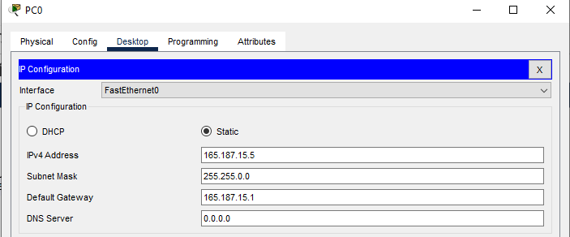

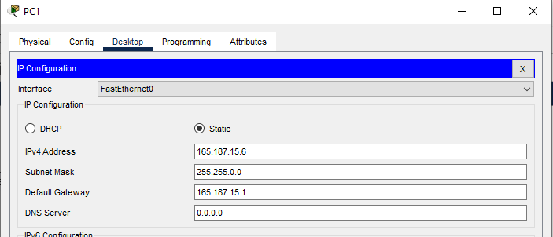

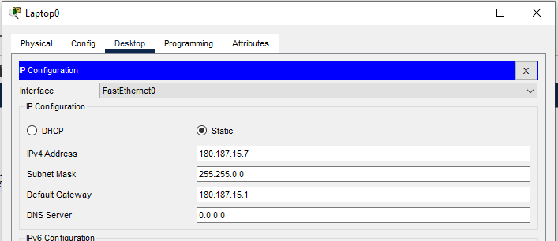

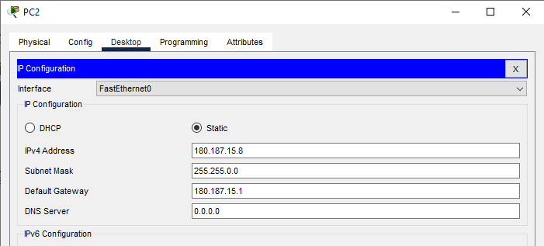

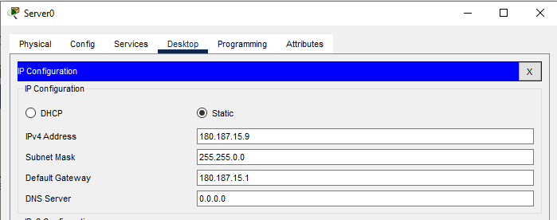

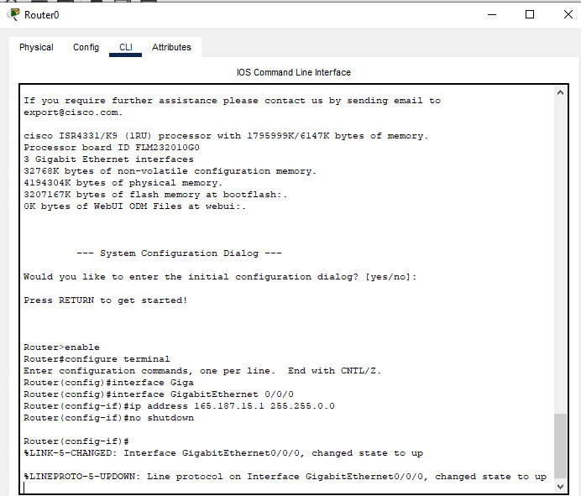

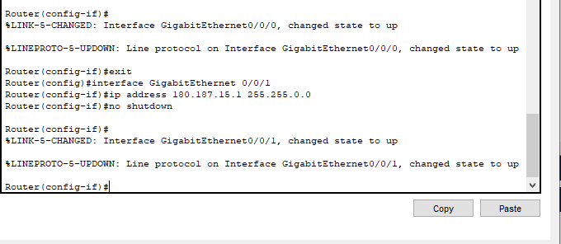

**FOR HTTP RESPONSE:**

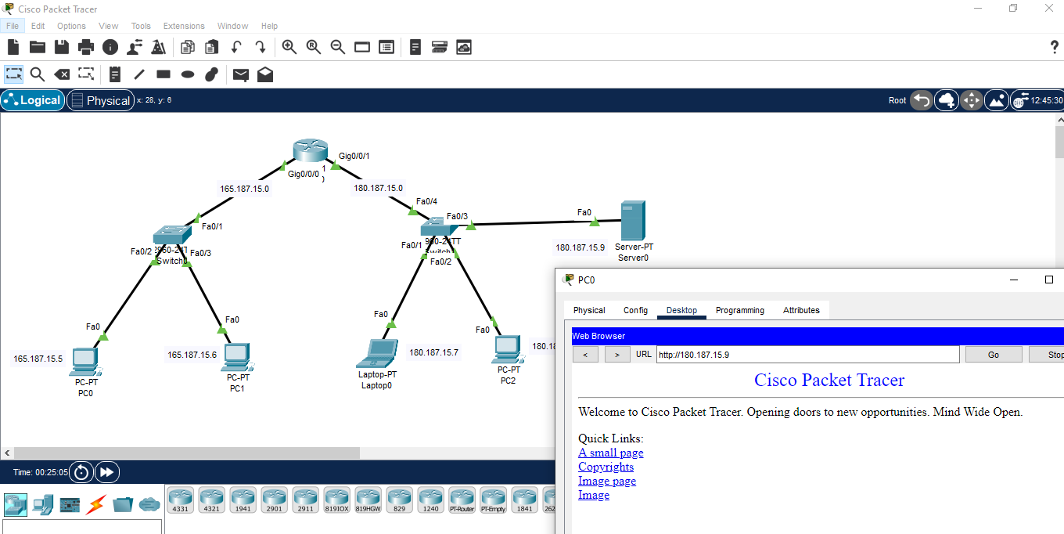

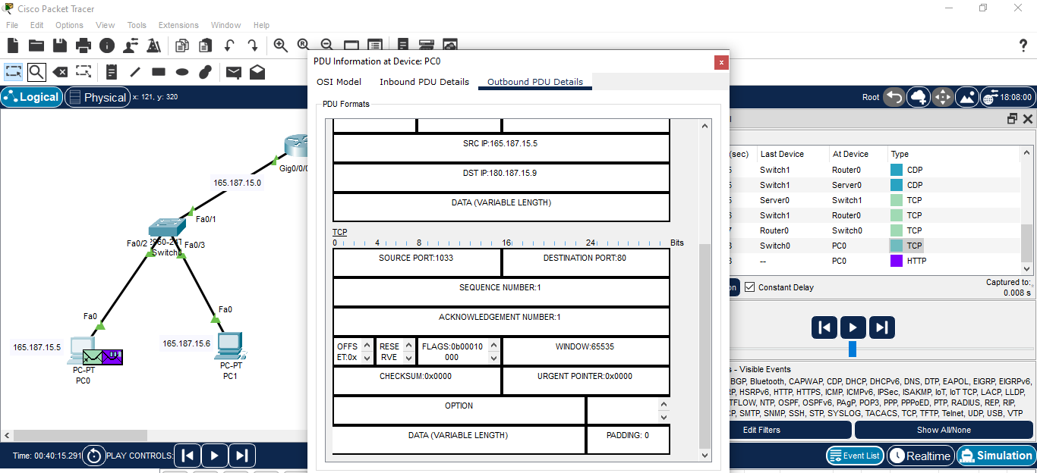

**FOR HTTPS RESPONSE:**

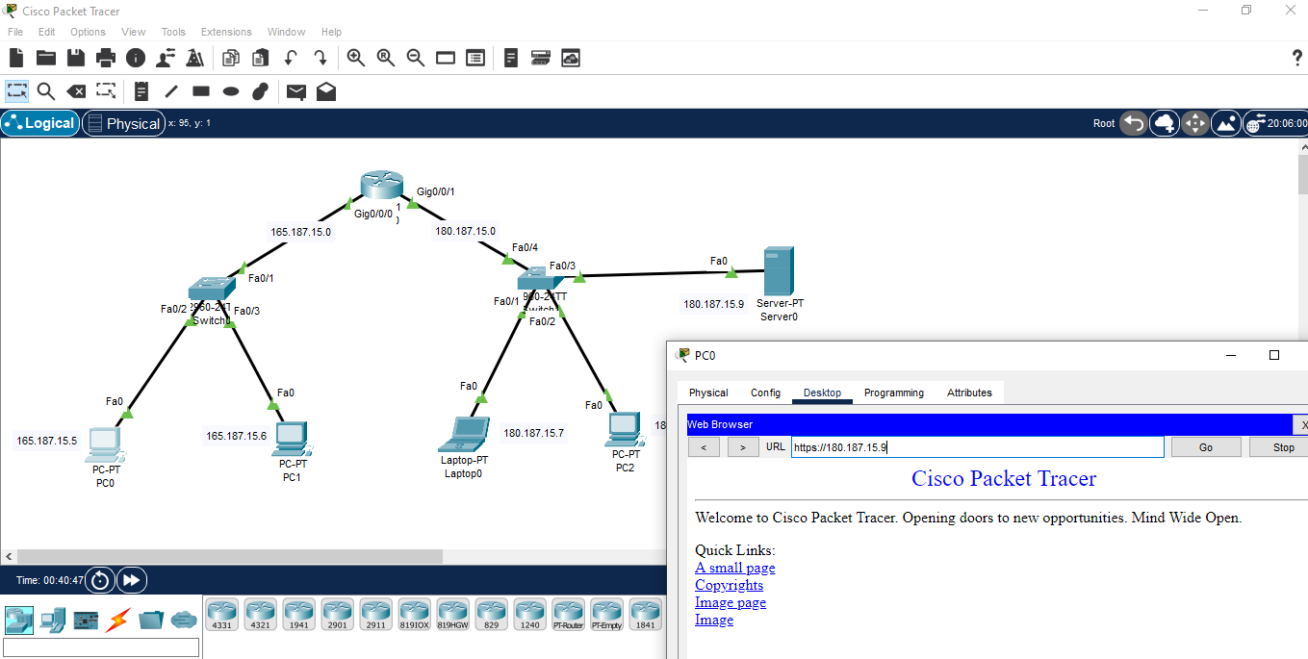

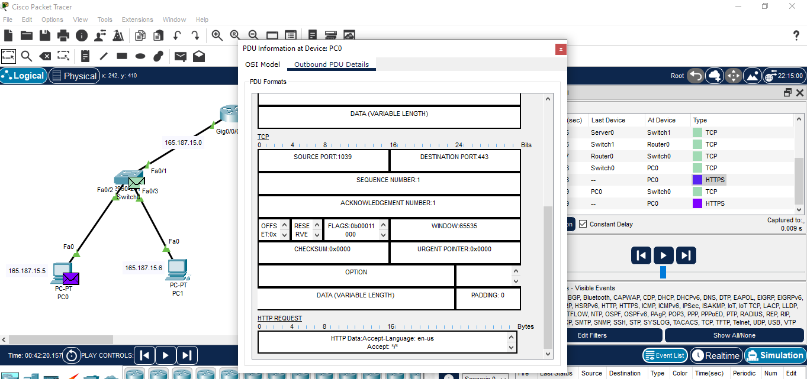

**Difference between HTTP and HTTPS**

|  |  |
| --- | --- |
| **HTTP** | **HTTPS** |
| **Port:** 80 | **Port:** 443 |
| Less secure as it transmits data in plain text. | More secure as it encrypts data and tranmit it in encrypted form. |